D. SAMPLE ― Proceeding Paper – shown only 1st and the Last pages for Full Papers

Three dimensional transition solid elements for mesh gradation

*Chang-Koon Choi1) and Nam-Ho Lee2)

^{1), 2)} Department of Civil Engineering, KAIST, Daejeon 305-600, Korea
¹⁾ cck@kaist.ac.kr

ABSTRACT

Enhanced three-dimensional finite elements for geometrically nonlinear analysis of cable supported structures are presented. The cable element, derived by using the concept of an equivalent modulus of elasticity and assuming the deflection curve of a cable as catenary function, is proposed to model the cables. The stability functions for a frame member are modified to obtain a numerically stable solution. Various numerical examples are solved to illustrate the versatility and efficiency of the proposed finite element model. It is shown that the finite elements proposed in this study can be very ……

1. INTRODUCTION

Many researchers have carried out investigations for the determination of damping ratio in solis. (Cadappa 2001) have suggested that a value of 5% can be taken as the contribution from material damping that can be added to radiation damping in order to obtain to ReSteel reinforced concrete composites (SRC) are useful in tall buildings subjected to earthquake or wind loads. The contribution of steel provides the structure with a higher stiffness, greater energy dissipation Cable-supported structures are used extensively to support cable-stayed bridges, suspension bridges, offshore structures, long span roofs, communication towers, and so on. Such structures are often more economical than conventional ones because of the high efficiency of steel members in simple tension. However, cable-supported structures are quite flexible so that they may undergo large displacements before attaining their equilibrium …

2. PROPOSED FAILURE SURFACE

The cable element, derived by using the concept of an equivalent modulus of elasticity and assuming the deflection curve of a cable as catenary function, is proposed to model the cables…

2.1 Normal and AA
It has a six-fold symmetry, and is adequately defined by a tensile meridian (when the angle of similarity)…

High-strength concrete The mathematical definitions of nodal vectors V2i , V1i and V3i can be found in Chern (1992) and are illustrated in Fig. 1

(1)

The cable element for the modelling of cables is derived by using the concept of an equivalent modulus of elasticity and by assuming the catenary function as deflection curve of a cable. The equivalent modulus of elasticity as shown in Eq. (1)
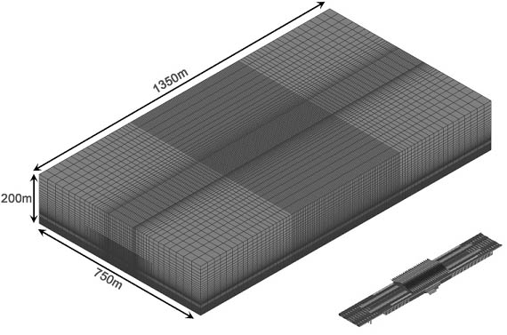
Fig. 1 Computational meshes for Gyeongju station

The numerical examples have illustrated that the proposed finite elements could be very useful for geometrically nonlinear analysis as well as free vibration …

3. CONCLUSIONS

Enhanced and efficient 3-dimensional finite elements for the structural analysis of cable-stayed bridges …

REFERENCES

Cadappa, D.C., Sanjayan, J.G. and Setunge, S. (2001), “Complete triaxial stress-strain curves of high-strength concrete,” J. Mat. Civil Eng., ASCE, 13(3), 209-215.
Chern, J.C., Yang, H.J. and Chen, H.W. (1992), “Behavior of steel fiber reinforced concrete in multi axial loading”, ACI Mat. J., 89(1), 32-40.

1) Professor
2) Graduate Student

